Southern University at New Orleans
SUS-SUNO/LA Dept. of Health, CDC/State of LA Health Disparities Project

Application Form

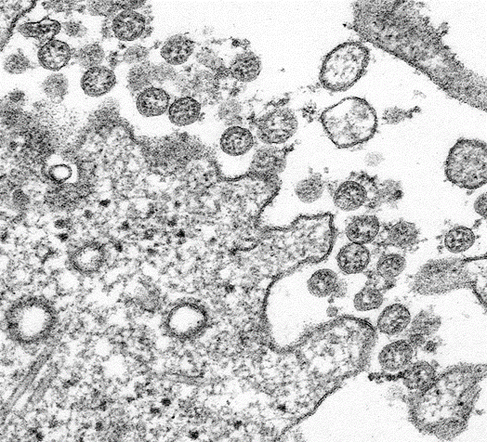1. 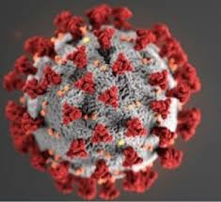2.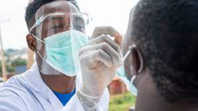 3.
Courtesies: CDC/Stanford Health Care/Health Affairs: Transmission electron microscopic image of an isolate from the first U.S. case of COVID-19, formerly known as 2019-nCoV. 1. The spherical extracellular viral particles contain cross-sections through the viral genome, seen as black dots; 2. Model of n19coronavirus; 3. and Taking deep Nasal Sample for testing.

Southern University at New Orleans (SUNO) will host two (2) years Health Disparities training for undergraduate students (Spring 2024). The work is aimed at ‘Southern University and A&M College (SU) to support SU’s initiatives to improve COVID-19 health outcomes, reduce health disparities, and increase diversity in Louisiana’s healthcare workforce’ focused on increasing awareness and preparedness on COVID-19 disease health disparities among populations at high-risk and underserved, including racial and ethnic minority populations and rural Communities by training SU students funded by LA Dept. of Health/State of Louisiana and mandates activities in the following areas:
- Clinicians analytical training/internship/mentoring/supervision for prospective Students in Medicine, Allied Health, Nursing, Dental, Pharmacy, Postgraduate Biomedical sciences and Health and Allied Health Career Capacity Development;
- Host STEM & healthcare careers (medical, nursing, pharmacy, dental, allied health) impact days at K-12 schools located in vulnerable communities (evidenced by low attendance and graduation rates).
- Vaccinations, Vaccine Acceptance or reduce Vaccine hesitancy to prevent COVID-19 infection and spread in the SUNO Community, Surrounding Communities, Greater New Orleans and Elsewhere.
- Host health fairs in vulnerable communities with known health disparities due to decreased healthcare access, low rates of health literacy & compromised social/political determinants of health.
- careers (medical, nursing, pharmacy, dental, allied health) and Louisiana Bar examinations.
- Host various trainings for students enrolled in healthcare (medical, nursing, pharmacy, dental, allied health) on cultural competency, social/political determinants of health, and health literacy.
- Host community educational fairs to raise awareness of the impact current policies, social/political determinants of health, and health literacy have on our local communities.
- Increase awareness of health justice & equity by expanding instruction for students on the impact of public health policies, social/political determinants of health, and health literacy have on our local communities.
- Provide programming around access to healthy food options in vulnerable communities, including K-12 and graduate school campuses.
- Provide technology for students pursuing education in STEM/healthcare.
- Provide funding support for healthcare students and professionals to attend national health equity trainings and conventions.
- Develop and purchase print, online and marketing materials for community outreach events and programs.

The current grantof Spring 24 is at SUS Campuses; SUBR, SUNO, SUSLA, SU Law Center and SU AgCenter. Students will be engaged in additional activities; Develop Infectious Disease, Disability/braille Accommodation curricula, provide skills training in collection, chain of custody, identify COVID-19 viral DNA sequences isolated from groups in communities and within our University to estimate their occurrence and frequency among others.

Students will be paid $2,500 per Spring/Fall semester ($4,000 for Summer analytical training) equivalent for full work per semester cycle upon completing their allocated Health Disparities project. Students will need to sign a contract form on the first day of the work activities.

Deadline for the application is February 14 2024. Please either fax your application with transcript to (504) 284-5475 or email to Professors at cclement@suno.edu or rbelmasrour@suno.edu or ksmith@suno.edu or melaasar@suno.edu or lmims@suno.edu not later than February 14 2024

Required Documents: 1. Application Form with signature
2. Transcript (a copy is acceptable)

For more information, please contact:

Dr. Christian Clement-Director/PI
Email: cclement@suno.edu
Office Phone: 504-284-5406

Dr. Rachid Belmasrour-Coordinator/Co-PI
Email: rbelmasrour@suno.edu
Office Phone: 504-286-5116

Dr. Kelly Smith-Co-Director/Co-PI
Email: ksmith@suno.edu
Office Phone: 504-286-5023

Dr. Mostafa Elaasar-Co-Coordinator/Co-PI
Email: melaasar@suno.edu
Office Phone: 504-286-5036

Dr. Lisa Mims-Devezin-Co-Coordinator/Co-PI
Email: lmims@suno.edu
Office Phone: 504-286-5064

NOTE
STUDENTS WHO APPLY INCLUDING CONTINUING INTERNS SHOULD ALL APPLY AND WILL SIGN A SEPARATE CONTRACT TO COMMIT TO WORK FULLY FOR THEIR STIPENDS.

Southern University at New Orleans
SUS-SUNO/LA Dept. of Health/State of LA Health Disparities Project

Application Form

Information Page:

Student’s Name: Gender: DOB:

Mailing Address:

Email Address:

Telephone (cell phone):

How did you hear about the Health Disparities?

Student’s Signature Date

Your signature indicates that you have validated the accuracy of the information provided above. Applications without a transcript will not be processed.

Please either fax your application with transcript to (504) 284-5475 or email at cclement@suno.edu or rbelmasrour@suno.edu or ksmith@suno.edu or melaasar@suno.edu or lmims@suno.edu no later than August 31 2023.

Additional Information (optional)

Title of Student Analytical Training:

Analytical Training area of focus (summary):

